PHP Tutorial – updating database records via a web interface part 1

In this tutorial we are going to look at a basic and not very user friendly way to use a web forms and a php script to allow the user to update existing records in a database table via a web interface. In a later tutorial we will see how to do it in a much better way. Before doing this tutorial you should have done the newnumyspace, forms, and the previous PHP tutorials.

In the following exercises remember that you will then need to upload copies of each file you create onto your web space on the newnumyspace web server and that to test them you need to enter the appropriate web address into the address bar of your web browser.

Pre-task: Creating the database table that we will need

For this tutorial you will need to have the database table called film created in phpMyAdmin. You should have created it in “PHP Tutorial 4 – using phpMyAdmin and querying databases”. If you haven’t, go to that tutorial now and follow the steps to create the table. It has the following field structure.

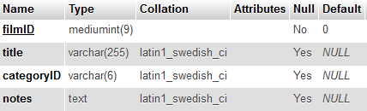

Exercise 1: modifying an existing record in our database table

In this exercise you will create a web page that contains a web form that allows the user to enter modified details for an existing database record and a PHP script to update that record in the ‘film’ table using the details entered via the form.

- Enter/copy the HTML code given below into a new HTML5 web page (remembering to use the basic HTML core tags as a basis first) and save it as modifyFilmForm.html. It will contain a form that will allow the user to:
- Enter the film
  - ID of the film that they want to modify
  - title, category and notes about the film
- Click a submit button with the label “Update film”

<h1>Modify a film</h1>
<p>Please enter updated details for the film you want to edit and click 'Update film'.</p>
<form id="modifyFilm" action="modifyFilm.php" method="get">
Film ID <input type="text" name="filmID">
Title <input type="text" name="title"><br>
Category
<select name="categoryID">
<option value="c8">buddy</option>
<option value="c5">classic</option>
<option value="c4">comedy</option>
<option value="c1">documentary</option>
<option value="c2">drama</option>
<option value="c3">epic</option>
<option value="c10">horror</option>
<option value="c7">music</option>
<option value="c9">sci-fi</option>
<option value="c11">series</option>
<option value="c6">thriller</option>
</select><br>
Film notes<br>
<textarea name="notes" style="width:500px; height:120px;"></textarea>
<br />
<input type="submit" value="Update film">
</form>

When viewed in a web browser it should look something like this:
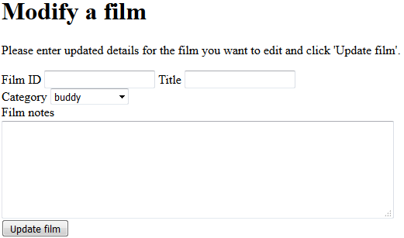

Please note that the html provided has been kept deliberately basic for the purposes of clarity. It does not, for example, contain accessibility features (like field sets, legends, labels and access keys). Also, the form has a basic layout and uses br tags for spacing rather than using CSS to style the layout and other features of the form using the method covered earlier in the module. You should add accessibility features yourself and improve the styling (and make any other changes that you think may be required) of course after the workshop.

- Create a PHP script called modifyFilm.php (remembering to use the basic HTML5 core tags as a basis) that will update the film record in the ‘film’ table of your MySQL database using the details entered via the form and SQL. It should:

- Connect to the database
- Extract the data sent by the form which is in the Request stream
- Put the data from the Request stream into variables
- Use that data to modify the record in the film database table using the details from the web form to update the title, categoryID and notes fields of the record with the film ID entered using an SQL update statement. Remember to use the filmID in a WHERE clause so only one record is updated
- Output a message to the web browser to indicate that the record has been updated in the database. Perhaps it should also give details of the updated record and display a link back to the update form

- Use the web form to modify one of the films and then check whether the film record was updated using the phpMyAdmin web interface. Note that you will need to manually enter details of each field, including the film ID

How could we improve on the previous update example? We could allow the user to select a record to modify from a list of records and then have the current details for that record displayed in a form ready to change. In the next tutorial we look at how to do that.

Challenge - handling undefined index errors, mandatory fields and special characters

- Make sure that you have added code in your PHP script to prevent undefined index errors. Hint: use isset()
- Modify the PHP code so that it either displays the film ID if the user entered one or otherwise displays a message prompting the user to do so. Do the same for the title, category name and notes. Hint: use empty()
- Modify the PHP script so that it escapes any special characters that may have been entered in the title. Hint: use real_escape_string()
- Do the same for film ID, category and film notes

Extra challenge – try to modify the PHP code so that the database record is only updated if a film ID, title, category and notes were provided.

Directed learning – deleting a film record
If you have time in the workshop attempt this challenge, otherwise attempt it as directed learning. For this challenge you will you will create a web page that contains a web form that allows the user to enter the film ID of an existing database record and a PHP script to delete that record from the ‘film’ table using the film ID entered via the form.

- Create a new web form that allows the user to:
  - Enter the film ID of the film that they want to delete
  - Click a submit button with the label “Delete film”

- Create a PHP script called (remembering to use the basic HTML5 core tags as a basis) that will delete the film record in the ‘film’ table of your MySQL database with the film ID entered via the form. It should:
  - Connect to the database
  - Extract the film ID data sent by the form which is in the Request stream
  - Put the film ID from the Request stream into a variable
  - Delete the record in the film database with the film ID entered using an SQL delete statement. Remember to use the filmID in a WHERE clause so only one record is deleted. Note that it’s very important to get the WHERE clause correct, else you can delete all records in the entire table!

  - Output a message to the web browser to indicate that the record has been deleted

- Use the web form to delete one of the films and then check whether the film record was deleted using the phpMyAdmin web interface
- Make sure that you have added code in your PHP script to prevent an undefined index error
- Modify the PHP code so that IT displays a message prompting the user to enter a film ID if they have not done so. The code should only attempt to delete a record from the database when a film ID has been provided
- Modify the PHP script so that it escapes any special characters that may have been entered in the film ID.

